**DESIGN AND DEVELOPMENT OF PERSONAL INFORMATION SYSYTEM**

This project “**PERSONAL INFORMATION SYSTEM**” is for computerizing the process which has been done manually in an office. If we take any office the information, we have to computerize are employee details like personal information includes name, id, contact information, date of joining, salary, attendance details.

In an office to maintain all activities manually is cumbersome work. For instance, if the user wants to search any details of employee or information about salary, attendance in an organization, they should refer the register and records, which is difficult to find out.

Through this software Employee welfare system, we are going to computerize an office process. So here every process will be done systematically. Above the all entries of employee, salary, attendance, department, their medical benefit and designation can be computerized in systematic manner. It reduces the complexity of paper work, and increase the work output.

A person with minimum computer knowledge is able to interact with this system. To make user friendly in practical this project is developed using **JAVA** and the details will be stored in **MS-SQL Server**.

**SYSTEM SPECIFICATION**

**HARDWARE SPECFICATION**

* Processor : P 4 700 GHz.
* RAM : 4 GB RAM
* Hard Disk Drive : 180 GB

**SOFTWARE SPECIFICATION**

* Operating System : Windows 7/8/10
* Front End : JAVA
* Back End : SQL

**MODULES**

1. Login Module
2. Employee Registration
3. Salary management module
4. Leave Module
5. Attendance Module

**Login Module**

Admin and employee both can login this portal. Every user has own credential. Which make secure to display the details. Users can’t see others users’ details.

**Employee Registration**

This module has to use to collect the employee information and save into the database. Once the employee registration has been completed, they will get username and password, when need to login just use this credential to move login page.

**Salary Management Module**

Salary management module is used managing the salary details for employees. Admin can manage all the employee’s salary details. Every month we can generate the pays lip by admin.

**Leave Module:**

Employee should send the leave request before taking a leave. The request was accepting by administrator. If the administrator does not accept the leave request employee can’t to take a leave. So, manager can find who are all taking a leave on today.

**Attendance Module.**

An Attendance module is main part of our project. Which could help to find employees daily punch report, the we can manage our attendance report.

**Data Flow Diagram / USE Case Diagram**

**LEVEL 0**

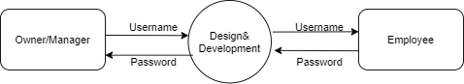

**Level 1**

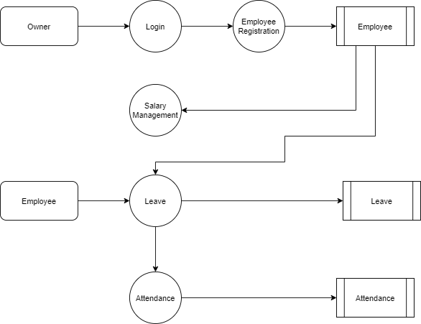

**ER Diagram**

